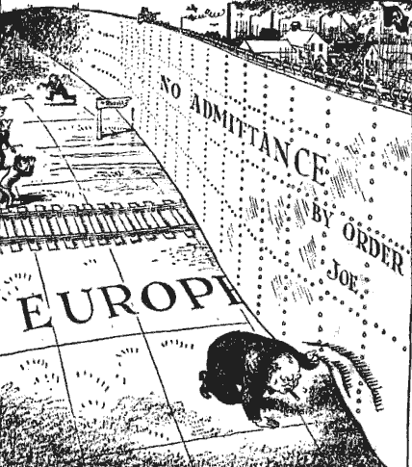
What are your initial reactions to this source?
________________________________________________________
*When analyzing a cartoon source it is important to following the following steps:
Step 1: Circle any important features on the source and consider their importance
Step 2: What is the cartoon referring too? Usually a cartoon will refer to an event or something that is happening in the world. E.g. Churchill’s Iron Curtain speech.
- The cartoon is referring too, “……………………”
Step 3: Consider the meaning of the circled features
- The cartoon depicts……… (Describe a feature of the cartoon)
- Which tells us that / which means…… (Explain the meaning of the meaning of the feature)
- It also shows……… (Describe another a feature of the cartoon)
- Which means…….. Explain the meaning of the meaning of the feature

Step 4: Comment on the cartoonist’s point of view
- The cartoonist is clearly …………. (in favor of / against) , (a capitalist / a communist)
- The cartoonist wants us to believe / think / be aware of / understand ……….

