We already know that the Basic Economic Problem is scarce resources and infinite wants. So we therefore need to make choices.

Economic choice is deciding between different uses of scarce resources
It is the next best alternative forgone when making a choice
i.e. it is what we give up when we make a choice.
Examples of Opportunity Cost
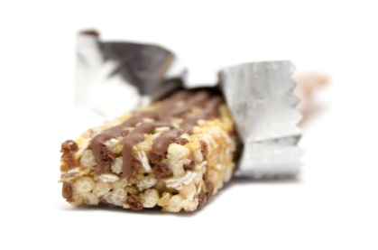
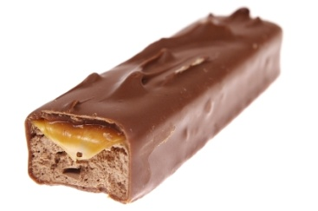
The opportunity cost of a

is a
chocolate and cereal bar chocolate and caramel bar
Now think of two examples of opportunity cost yourselves (one must be personal and the other for a business)
- Think of an opportunity cost that you have experienced recently
a) with money
________________________________________________________________________________________________________________________________________________________________________________________________________________________________________________________________
b) with your time

________________________________________________________________________________________________________________________________________________________________________________________________________________________________________________________________

- What could be an opportunity cost of you going to university after you graduate?
________________________________________________________________________________________________________________________________________________________________________________________________
- State one opportunity cost your school may have.
________________________________________________________________________________________________________________________________________________________________________________________________

