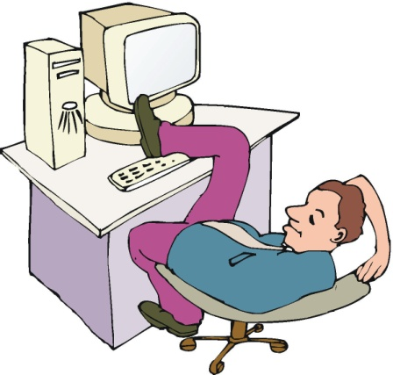
Reduce incentive to work
Raising taxes on income and profits reduce work incentives, employment and economic growth. As productivity falls the cost of production in many firms will increase and they will be less able to compete against producers from other countries. An effort to reduce aggregate demand may cause disincentives to work, if this occurs there will be a fall in productivity and therefore supply could fall.

Adverse effect of lowering Public Spending
Reduced government spending to increase aggregate demand could adversely affect public services such as public transport and education causing market failure and social inefficiency.

‘Crowding out’ effect
With an increase in government expenditure, there will be greater competition for limited resources. This will go against private investments resulting in shrinking of the private sector. To pay for new schools, hospitals and other infrastructure the government may borrow money from the private sector and therefore the more money the private sector lends to the government, the less it has to spend for itself.
The government may also raise interest rates to encourage people, firms and banks to buy government bonds the government could raise interest rates. When interest rates are high it is a good time to save money rather than to spend it. Firms also could be discouraged from borrowing money to invest in new machinery and factories.

Implementation of the Policy
Planning for the spending is done once by most of the governments. If there is a delay in the implementation of the fiscal policy, it might reduce the effectiveness of the policy. Thus the time lag is important.

