Being able to analyzing and interpret images (paintings, photographs and cartoons) is just as much as an important skill for an historian as being able to work with written documents. As we move through the presentation on the Great Wall. Complete the following table with your partner.

What do you see in the image? | What are the dominant features? | What can you infer?
_____________________  _____________________  _____________________ | _____________________  _____________________  _____________________ | _____________________  _____________________  _____________________
_____________________  _____________________  _____________________ | _____________________  _____________________  _____________________ | _____________________  _____________________  _____________________
_____________________  _____________________  _____________________ | _____________________  _____________________  _____________________ | _____________________  _____________________  _____________________
_____________________  _____________________  _____________________ | _____________________  _____________________  _____________________ | _____________________  _____________________  _____________________
_____________________  _____________________  _____________________ | _____________________  _____________________  _____________________ | _____________________  _____________________  _____________________
_____________________  _____________________  _____________________ | _____________________  _____________________  _____________________ | _____________________  _____________________  _____________________
_____________________  _____________________  _____________________ | _____________________  _____________________  _____________________ | _____________________  _____________________  _____________________
Read the passage on The Great Wall. When you’re finished discuss the reading with a partner. After this, finish the statements on the following sheet.

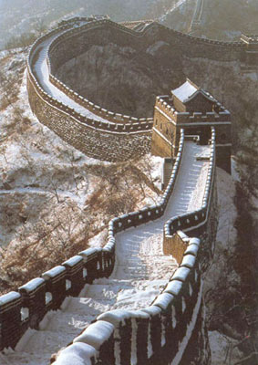
The Great Wall of China is the longest structure ever built. It is about 4,000 miles long, and it was built entirely by hand. About 1, 200 - 1, 500 miles of the Great Wall were built during the reign of Emperor Shi Huangdi (Qin Dynasty). The Great Wall crosses northern China from the east coast to the central part of China.

The Chinese built walls along their borders as early as the 600's B.C. During the Shang and Zhou dynasties, walls were built between Chinese regions that were fighting with each other. Walls were also built to protect China from outside invaders.

Emperor Shi Huangdi of the Qin dynasty (221 - 206 B.C.) was the first ruler to think of the idea of the Great Wall. He thought of connecting existing, older walls with sections of new wall. The building of the Great Wall continued into the Han and Sui dynasties. Parts were added in the Ming dynasty, too. Emperor Shi Huangdi ordered the building of the Great Wall to keep the enemy (the Mongols) from attacking his empire. The northern part of his empire did not have many people in it, so enemy invaders could move in easily.

Emperor Shi Hunagdi stated that the wall should be six horses wide at the top, eight horses wide at the bottom and five men high. The emperor's soldiers grabbed criminals, troublemakers, musicians, teachers, writers, artists, and humble peasants to help build the Great Wall. In all, about one million people marched north to build the Great Wall. Every one hundred yards, the workers built watchtowers two stories high. From the watchtowers, the Mongols could be seen coming, and warning signals could be sent. This prevented the Mongols from making surprise attacks. There were also gates built into the wall so that there could be trade and communication with the outside world.

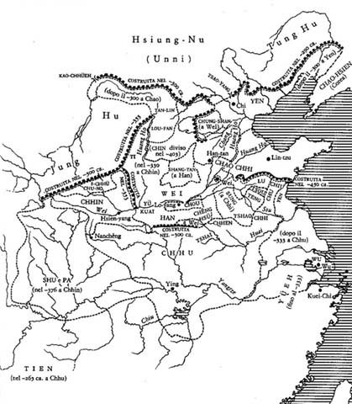
The Chinese worked throughout the day and night. Workers who complained or who tried to run away were buried alive. Many Chinese spent the rest of their life building the Great Wall. Many times, dead Chinese were buried in the wall. The Great Wall is sometimes called the "Long Graveyard" because so many people died while building the wall.

The wall wound up and down the mountains. It was built with dirt, stone and bricks. At the top of the wall, a roadway paved with three layers of brick connected the watchtowers. The roadways were wide enough to hold ten soldiers side by side.

The Great Wall was so strong that the Mongols did not threaten China again for more than one thousand years. The last improvements to the wall were made between 1368 C.E. to 1644 C.E. Today, much of the wall lay in ruins. The wall no longer serves the purpose of defending China, but it does attract many tourists.
How useful were the images and document in helping you to understand the Great Wall?

Analyzing images of the Great Wall

The presentation depicted ____________________________________________________ which would suggest that ______________________________________________________________.

Based on the image of the/a we can infer that _________________________________. This tells us that ____________________________________________________________________.

These images would be useful to an historian studying _______________________________ as they show ____________________________________________________________________.

An image ______________________________________________ would be useful because it would show us ________________________________________________________________.

Analyzing the document

The document states ____________________________________________________ which would suggest that ______________________________________________________________.

Based on ______________ we can infer that _________________________________. This tells us that ____________________________________________________________________.

This document would be useful to an historian studying _______________________________ as it tells us / because _____________________________________________________________.

A document from ______________________________________________ would be useful because it would tell us __________________________________________________________ .

Additional documents / images

Think about what kind of document / image would be helpful in aiding your understanding?
  - A primary source
  - A letter (public, private, a response)
  - A survey or poll
  - A diary

How useful were the images and the document in helping you to understand the Great Wall?
*Now write you paragraph in your notebook

