LANDUSE REVISION

It has been suggested that towns and cities do not grow in a haphazard way but tend to develop recognisable shapes and patterns. Geographers such as Burgess and Hoyt have offered theories as to how these characteristic shapes and patterns develop.

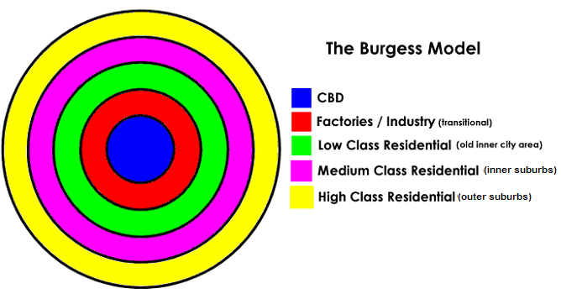
TASK

In your groups please decide which area/sector of the Burgess model the following types of building or industry would be in. (You need to write after each the sector it would be in)

Old factories |  | Low-cost housing estate
Tightly packed housing |  | New designer apartments
Shopping mall |  | House with back yard
SMBC Bank |  | Local corner shops
Leisure Centre |  | Fields
Government offices |  | Warehouses
Semi-detached house |  | New 11-16 school
Large park |  | New football stadium

